

SIMATS ENGINEERING

Saveetha Institute of Medical and Technical Sciences
Chennai- 602105

Student Name:K.LOHITH KUMAR Reg. No.:192511155
Course Code: CSA0927 Slot: D
Course Name: PROGRAMMING IN JAVA
Course Faculty: Dr .S.PUSHPALATHA
A SMART EVENT MANAGEMENT FRAME WORK FOR REAL TIME CROWD MONITORING,SECURE ENTRY,AND PREDICTIVE ANALYTICS
Module Photographs: (3 photographs –Module Photo, Individual student contribution module work in the project and presentation image)
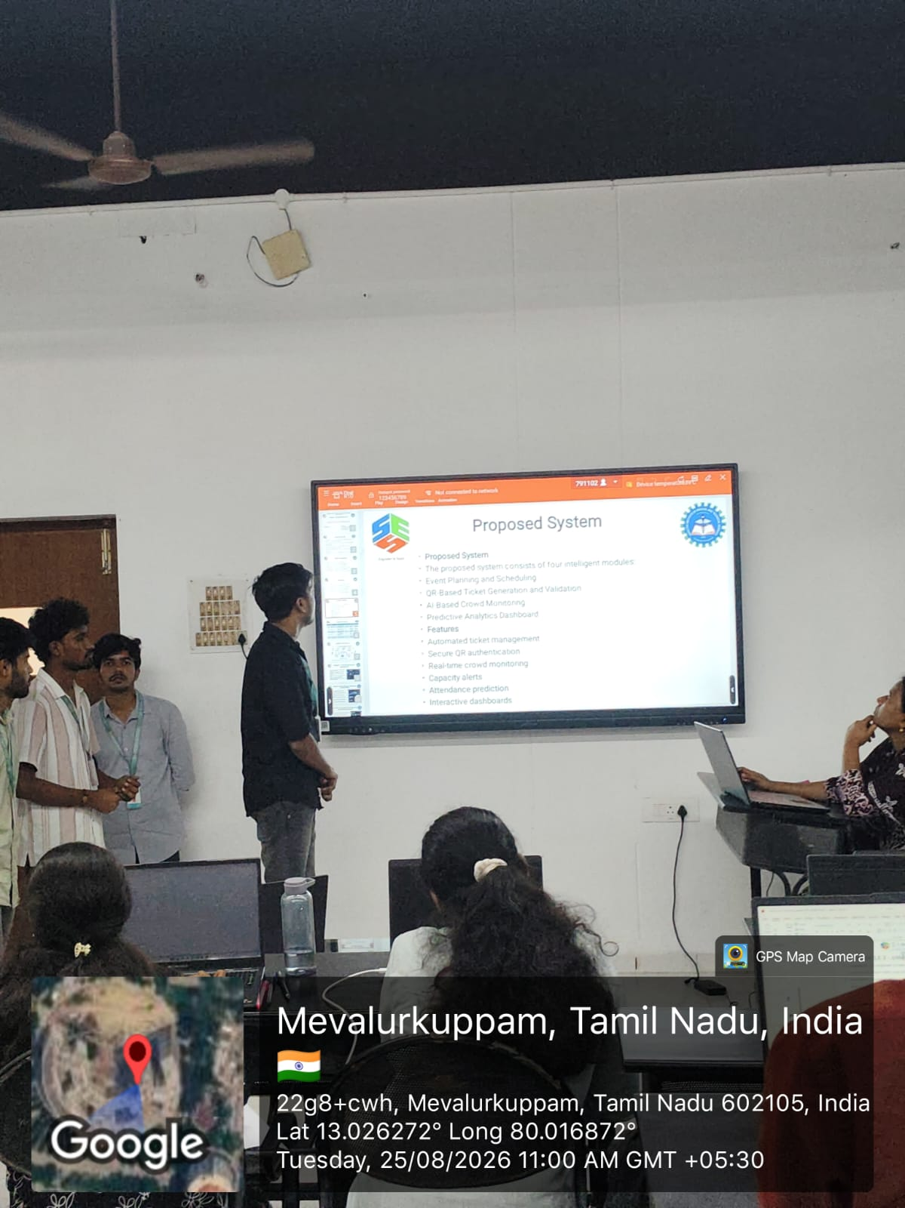
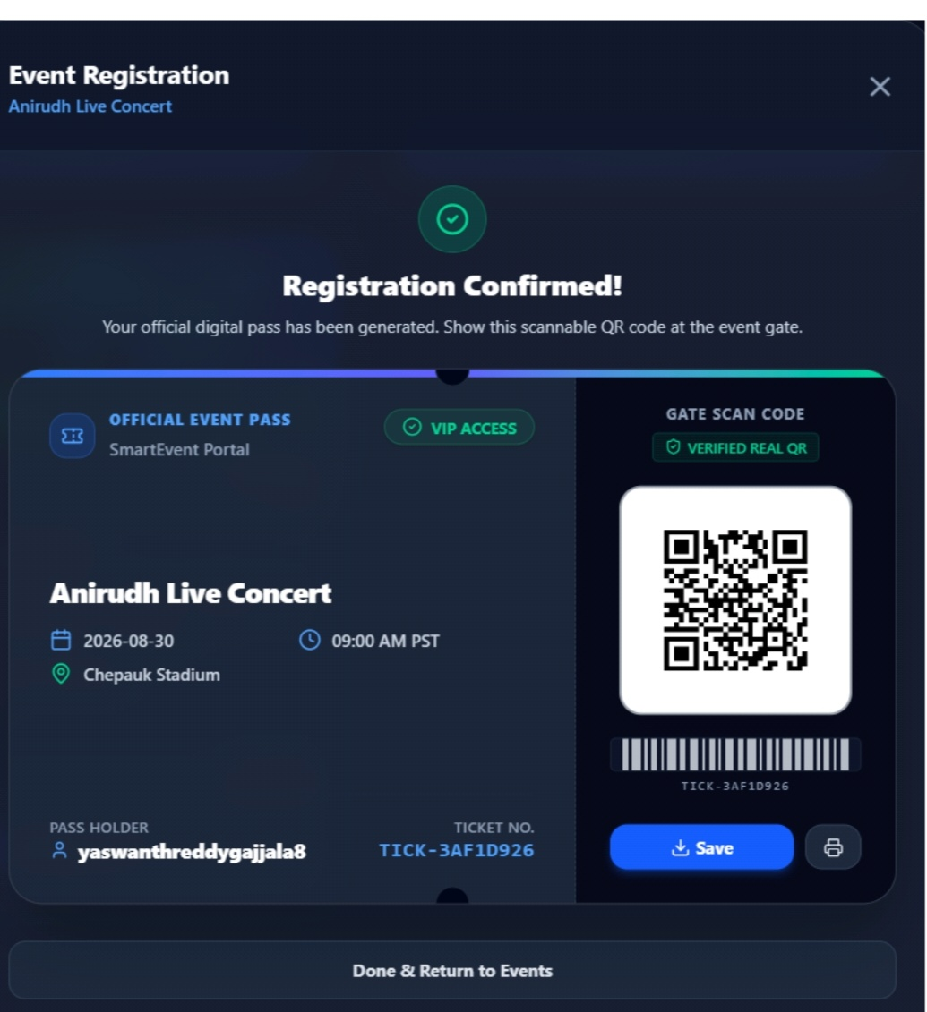
Project Description: (here you write what you did in this project (contribution) including Model Description
The framework collects and analyzes information such as crowd density, zone occupancy, entry and exit counts, and safety conditions. A centralized dashboard displays the current crowd status of important areas such as the entrance gate, main stage, food and beverage area, VIP lounge, and other event zones. The system also provides automated alerts when the crowd in a particular area exceeds a predefined safety threshold. This allows security personnel and event organizers to take immediate action, such as controlling entry, redirecting people, or deploying additional security staff.

LOHITH
Student Signature Guide Signature

